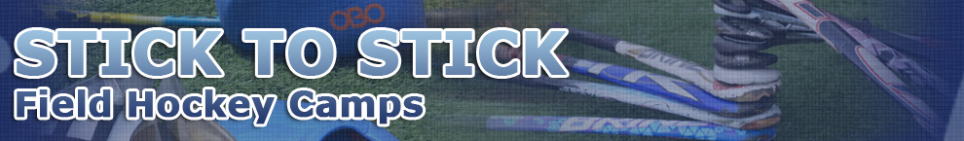
Thank You for Registering for the 2017 Stick To Stick Field Hockey Camp!
Directions by Car
Denison University is located just 27 miles east of downtown Columbus. From the East, West and South: Denison is less than 10 miles north of Interstate 70 (Exit 126) on Route 37. From the North, you should exit Interstate 71 at Bellville and take State Route 13 south into Mt. Vernon. From there, Route 661 south will bring you the 23 miles to the back entrance of Denison.
Denison University Map It!
Traveling by Air
If your child will not be arriving by car please detach the completed form and return it to:

Stick to Stick Field Hockey
813 Northwest Blvd.
Columbus OH 43212

Forms must be received NO later than 10 days prior to camp. Campers arriving by Air: A shuttle service will be provided for campers arriving by plane to the Columbus Airport (CMH). The shuttle fee is $40 each way or $80 round trip. Campers need to schedule their flights to arrive and depart as following:

Arrive: 9:30-11:30 a.m. on June 10th Depart: 1:30-3:00 p.m. on June 13th

Camper’s Name ________________________ Cell Phone Number: ________________________________

Camper’s Scheduled Arrival at Port Columbus (CMH) June 10^{h}, 2017:

Arrival From: ________________Arrival Time: ______________Airline: ________________________ Flight # ___________

Camper’s Scheduled Departure from Port Columbus (CMH) June 13, 2017

Traveling To: ________________Arrival Time: ______________Airline: ________________________ Flight # ___________

